- Introduction
The Axiom project is an AI-enabled Red Team / Blue Team cybersecurity training platform built for InspireCyber. Assessment 1 set the foundation of the project by articulating the business problem and stakeholders, functional requirements and non-functional requirements, system architecture, cyber-training scenarios and implementation backlog.
Assessment 2 works on this foundation towards implementation planning, proof-of-concept development and validation. InspireCyber's current learning path involves cybers security and AI education via workshops, electronic learning, platform-based learning and other interactive training activities. Covering topics like security awareness, identity and access management, incident response and secure usage of AI, this model is though lacking the practical environment, as established in Assessment 1, where learners can acquire practical cybersecurity skills simulating offensive and defensive techniques in a workplace context where AI threats are faced.
Axiom tackles this by running constrained and gamified Red Team v Blue Team exercises with submissions on options including prompt injection, compromised chatbots and data leakage.It is not designed to be open-ended penetration testing 'free-from', rather learners are confined to sandbox simulation environments while a deterministic game engine retains control of the scenario state. The behaviour generated by AI could help with believability and diversity, but any output is still considered untrusted input and has to be validated before influencing the scenario.
  - Business Context and Problem Statement

InspireCyber in the cybersecurity and AI training field as a provider of online, digitally enabled training provided by instructors and used by organizations. These modes offer cybersecurity training and refer mainly to learning and awareness.
Assessment 1 identified that the InspireCyber platform does not yet exist where the learner of today will be able to revisit workshops and online courses that will allow for the practise of attacks and defence against AI issues in a more practical environment. Learners today have to utilize robots but not have the opportunity to work of their decision-making skills, recognitions of attack and containment and response activities in a Red Team/Blue Team context.
That is both a traditional cybersecurity capability gap & business opportunity. From a security perspective, theoretical knowledge does not prove actual ability for recognition of malicious activity & appropriate response. From a business perspective, InspireCyber is not providing a distinct product with AI-security instruction, gamification & quantitative Red/Blue outcomes.
The problem can then be stated as a lack of a controlled, realistic and measurable environment in which to conduct applied AI-security-training. Axiom solves this by permitting attempts at approved offensive or defensive actions between participants in simulated environments, with Axiom itself taking care of scenario state scoring logging and feedback. This is a direct extension of the problem outlined in Assessment 1.
  - Project Goals, Objectives and Success Criteria
The main objective of Axiom is to design and prove the effectiveness of a safe, feasible proof-of-concept for realistic Red Team versus Blue Team Cybersecurity training in an isolated AI-enabled scenario.
Assessment 1 concerned requirements architecture wireframes and scenario creation and design and a prioritised backlog.Assessment 2 moves these outputs toward implementation and validation by measuring it.These objectives indicate a deeper level of technical development, to deliver a fully commercial offering; the MVP gives a limited-level service to reduce the level of project risk.
ID | Objective | Success Criterion
OBJ1 | Develop one complete playable Red-vs-Blue AI-security scenario. | Scenario can be started, played and completed without critical failure.
OBJ2 | Maintain deterministic control of scenario state. | All valid player and AI actions are validated before changing scenario state.
OBJ3 | Implement role-based access control. | Unauthorised functions are rejected during access-control testing.
OBJ4 | Implement scoring, logging and feedback. | Valid actions generate consistent scores, event records and post-scenario feedback.

This also minimizes the scope of the project, and the requirements of the project team, to enable them to validate the platform's feasibility from a technical and cybersecurity perspective first.
  - Project Scope, Assumptions and Constraints
Assessment 1 was emphasis on analysis architecture wireframes and gameplay design, with implementation phase moved to Stage 2.
Category | Assessment 2 Definition
In Scope | Authentication, scenario selection, Red/Blue role assignment, one playable scenario, controlled actions, game engine, AI-assisted behaviour, scoring, logging and feedback.
Out of Scope | Enterprise deployment, LMS integration, large scenario library, advanced leaderboards, billing and unrestricted penetration-testing functionality.
Assumptions | Testing uses isolated environments and synthetic data; required AI services remain available; participants follow acceptable-use conditions.
Constraints | Academic timeframe, limited resources, unknown production budget/user scale, AI variability, external API limitations and privacy requirements.
Dependencies | Game engine, scenario rules, authentication mechanism, AI service and stakeholder validation.

Assessment 2 redefines the scope, by setting it around a limited POC.This is a natural extension from Assessment 1: what was missing: features like comprehensive scenarios and scoring were determined to be outside the scope of Stage 1 design in earlier stages.
The POC has been kept deliberately small to ensure the team can validate the most critical architectural, security, and gameplay assumptions before moving to wider deployment.
  - Stakeholder and User Requirement Analysis
The major stakeholders depicted in Assessment 1 still appear relevant still their needs are now on implementation and POC validation.
ID | Stakeholder | Role | Main Need | Influence
ST1 | InspireCyber | Project owner | Practical, secure and useful AI-security training POC | High
ST2 | Christina Arcane | Industry mentor | Progress, suitable design and alignment with training objectives | High
ST3 | Target learners | End users | Realistic, engaging and safe practical training | High
ST4 | Client organisations | Customers | Better capability against AI-related cyber threats | Medium–High
ST5 | Student project team | Developers/analysts | Clear scope, stable requirements and achievable POC delivery | High
ST6 | CIHE supervisor | Academic supervisor | Appropriate cybersecurity methodology and project quality | Medium–High

Functional Requirement (FR): authentication, scenario selection, team selection, Offense and Defense, Scenario-State validation scoring logging and Notification of events. Non-Functional requirements (NFR): security privacy usability, reliability performance modularity auditability etc.
The requirements are interrelated. Role-based access to support security as well as scenario fidelity; logging to support scoring, feedback and audit; isolation of the environment to support reduce cybersecurity and ethical risks of offensive training. The stakeholder model can so provide a traceable basis for later architecture, security control and test.
- Project Planning and Management
The project planning for Assessment 2 builds directly on the analysis and design work of Assessment 1 by taking it into a managed proof-of-concept phase. To remind, Assessment 1 generated the requirements baseline, architecture proposal, risk profile and priority implementation backlog, and suggested a testing regime of one 'end-to-end' Red Team-vs-Blue Team scenario before rolling out the platform. With that in mind, Assessment 2 adopts an MVP approach to delivery of Axiom, focusing on providing the technically uncertain and security-critical elements of Axiom first, while controlling scope, schedule and project risk.

  - Project Charter
The Assessment 2 charter takes the Stage 1 design results and makes them an implementation & validation baseline.
Charter Element | Assessment 2 Definition
Project Title | Axiom – AI-Powered Red Team vs Blue Team Cyber Training Platform
Industry Partner | InspireCyber
Purpose | Develop and validate a controlled POC demonstrating practical AI-security Red/Blue training.
Scope | One playable scenario incorporating role assignment, Red/Blue actions, deterministic scenario-state management, scoring, logging and feedback.
Key Stakeholders | InspireCyber, Christina Arcane, learners, client organisations, project team, CIHE supervisor and facilitator/trainer where confirmed.
Key Deliverables | Functional POC, refined architecture, security controls, testing evidence, risk evaluation and implementation recommendations.
Acceptance Criteria | Core scenario operates end-to-end; valid actions correctly alter scenario state; unauthorised/invalid actions are rejected; scoring and results are recorded correctly.
Project Authority | InspireCyber provides industry direction; the project team controls development under CIHE supervision.
Expected Value | Demonstrates whether Axiom can extend InspireCyber's training portfolio from recall-based learning into practical AI-security exercises.

The same charter as Assessment 1 has been used since it was decided to push the implementation and full playable feature into stage 2.

  - Project Roadmap / Gantt Chart
To validate the architecture and scenario rules before the commencement of dependant development and testing, a staged roadmap has been adopted. It needs to be preceded as Assessment 1 revealed multiple unresolved issues with scenario design scoring AI behaviour and trainer requirements. Forward machinery delays in resolving these upstream design decisions may impact down stream implementation, integration and testing activities.
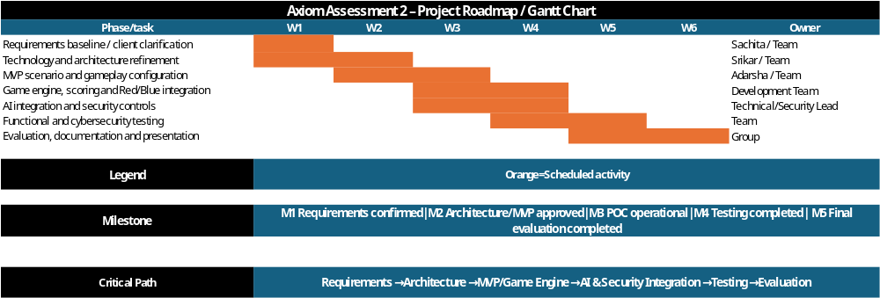
Figure 1. Axiom Assessment 2 Project Roadmap / Gantt Chart.
The roadmap brings a staged approach to the MVP delivery, where requirements certainty and architecture refinement is completed before further development activity that depends on this previous activity. After that the MVP scenario, game engine, Red/Blue functionality, AI integration and security controls are delivered before functional and cyber security testing. Key milestones include the confirmation of the requirements baseline, approval of the architecture and MVP scenario, completion of the end-to-end POC, completion of testing and the final evaluation. The critical path for activity runs from requirements and architecture to core development, to integration, testing and evaluation. This gives a sequence that mitigates re-work and offers a pathway for validating one complete Red Team versus Blue Team scenario before further platform enhancement as recommended by Assessment 1.
  - Team Roles and RACI Matrix
The Axiom project has developed a RACI matrix to broadly define individual roles and responsibilities, and to facilitate coordination across the 4 major workstreams. Sachita (Member 1) is mainly responsible for activities related to Introduction and Project Planning; Aadarsha (Member 2) carries the major responsibility for conducting Industry and Technology Landscape Analysis. Sebika (Member 3) is mainly responsible for activities related to Solution Design and Technical Architecture, and Srikar (Member 4) takes prime responsibilities for activities related to Proof of Concept implementation testing, evaluation, and conclusion. A job division like this plays to the natural flow of activities within the project, which proceeds from problem definition and planning, to research and design, to implementation and evaluation.
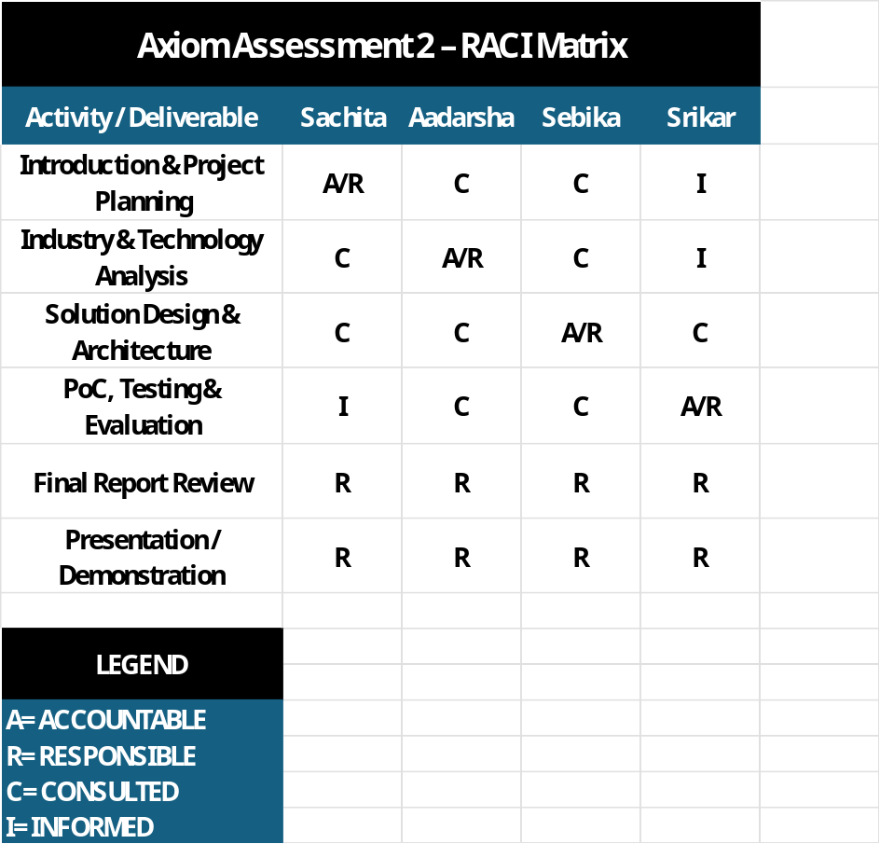
The same task structure is captured in the RACI matrix and represented graphically. It clearly indicates the members who have the responsibility accountability as well as those who should be consulted and informed for most the deliverables. Besides the final report integration and presentation preparation where every team members' support is needed, responsibility for each work stream is allocated mostly to the individual team members and the remaining team members are either informed or consulted when necessary. This task structure minimizes duplication of effort as well as helps improve accuracy of the project work as any related sections are kept consistent across the project. And, it enables effective communication because every team member is aware of their own responsibilities and how they fit into the overall group dynamic.
  - Risk Register
Assessment 1 employed a qualitative risk register, Assessment 2 needs to improve upon this, developing it into a quantified register consistent with the fresh brief.
Likelihood (L): 1–5
Impact (I): 1–5
Risk Score = L × I
Ratings: 1–4 Low, 5–9 Medium, 10–16 High, 17–25 Critical

ID | Risk | L | I | Score | Rating | Response / Mitigation | Owner
R1 | Unresolved/changing client requirements create rework | 4 | 4 | 16 | High | Mitigate: baseline requirements, record changes in Jira | Project Lead
R2 | AI behaviour bypasses scenario rules | 4 | 5 | 20 | Critical | Mitigate: deterministic engine, action-schema validation and logging | Technical/Security Lead
R3 | Offensive scenario content becomes reusable outside training | 3 | 5 | 15 | High | Mitigate: sandboxing, constrained actions, synthetic systems and acceptable-use controls | Security Lead
R4 | Team delays affect dependent implementation | 3 | 4 | 12 | High | Mitigate: Jira ownership, milestones and early escalation | Project Lead
R5 | Selected AI/platform technology is difficult to integrate | 3 | 4 | 12 | High | Mitigate: early POC testing and modular interfaces | Architecture Lead
R6 | Learner/privacy data is exposed or over-collected | 2 | 5 | 10 | High | Mitigate: minimisation, RBAC, secure transport and synthetic data | Security Lead

They can be traced back to Assessment 1, which noted shifting requirements, integration uncertainty, delays and version-control issues during development, and identified AI control and scenario isolation as the primary technical challenges.
  - Feasibility Study
Assessment 1 found the Axiom paper could go ahead to Stage 2, although no blanket claim was made that all questions of feasibility were answered. Operational feasibility was identified as most certain, technical feasibility was contingent on control over AI behaviour (through rejection of nondeterminism) and isolation of scenarios, legal feasibility was conditional, and economic feasibility was less certain (budgets, scale and AI-source no given).
Dimension | Rating | Assessment 2 Evaluation
Technical | High, conditional | Core scenario, scoring and role logic use feasible technologies. AI integration and scenario isolation must be validated through the POC.
Operational | High | Axiom extends InspireCyber's existing remotely delivered and facilitated cybersecurity training model.
Economic | Medium / Pending | POC delivery is feasible within student resources, but production TCO cannot be justified until scale, hosting and AI-provider costs are confirmed.
Legal | Medium | Learner-data handling, retention, third-party AI terms and applicable privacy requirements require confirmation before production deployment.
Ethical | Medium | Offensive training content must develop defensive capability without becoming transferable real-world attack capability; synthetic scenarios and acceptable-use controls reduce this risk.
Cybersecurity | Medium–High | Feasible if RBAC, secure communications, sandboxing, logging, data minimisation and deterministic AI validation are enforced.
The POC is so to prove, not to demonstrate. It is a form of feasibility-control: it validates the project's most risk-critical assumption in advance of InspireCyber adopting the necessary wider rollout. That's the point of three-fold Assessment 1 recommendation to show Red/Blue gameplay, scoring and scenario state in one pice de resistance scenario, before additional features are added.

